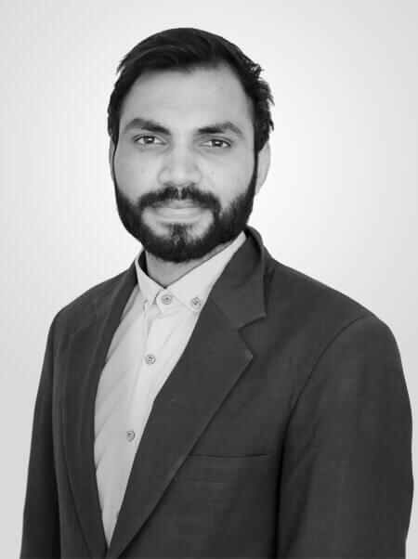

To pursue a challenging career and be part of a progressive organization that gives scope to enhance my knowledge, skills and to reach the pinnacle in the computing and research field with sheer determination, dedication and hard work.

2018 present | DTech Systems

* Design, implement and maintain code for different projects.
* Resolve issues and implement new functionality and features.
* Assist other engineers in development.
* Worked with QA team to improve products quality.
* Also, review the design of proposed features and implementations by other engineers.

Aug 2017 to Dec 2017 | PureLogics Company

**Associate Software Engineer**

**TECHNICALPROFICIENCIES:**

**Programming languages:** C, C++, PHP, JAVA

**Framework:** CodeIgniter, Laravel, Symfony

**Mobile Development:** Android

**Frontend:** JavaScript, jQuery, HTML5, CSS3, Bootstrap, React

**E-Commerce:** Magento 2

**Operating System:** Windows, Linux

**Tools:** GIT

**WEB DEVELOPER**

**CAREER OBJECTIVE**

**HOBBIES**

**EXPERIENCE**

**EDUCATION**

Ali Sultan Khan

**ABOUT ME**

**BACHELOR DEGREE**

Virtual University of Pakistan

Bachelor in Computer Science

Date of Birth: August 27, 1994Age: 25Gender: MaleBirth Place: Lahore, Pakistan

Certifications:Learn Web Development from Scratch (Coeus Solutions GmbH)

**Intermediate**

Intermediate Computer Science (ICS)

**CONTACT**

Government Degree College

16-A Sarmad Street Tag Bagh, Lahore

+923340755657

alisultankhan640@gmail.com

**INTERESTS**

Algorithms

Problem Solving

Mobile Development

**Software Engineer**

Machines

Data Structure

Object Oriented Technology

* Worked on Dtech product Point of sale (POS).
* Worked on Different mobile apps backend API’s development.
* Working closely with agile development team to develop, test and maintain Web- and mobile apps software applications.
* Worked on Darussalam.com, Payment methods integration, eBay and Amazon integration.

**Projects**

* **Project**: Classified and swapping product website
* **Technology**: Symfony, MySQL, JQuery, HTML, CSS
* **Swapstyle**
* **NGO Management System**
* **Project**: Classified website
* **Technology**: PHP, MySQL, JQuery, HTML, CSS

* Attentive listening and effectiveoral communication skills
* Great at Problem Solving
* Good Leadership Skills
* Ability to quickly create andapply ideas and solutions
* E-Commerce, Object-Oriented Design, Web Services (REST/SOAP), API's,
* Object-Oriented Design
* UI Development [ HTML, JS - jQuery, CSS
* Database Design, Normalization, Modelling and Optimization, ORM(Eloquent)
* Codeigniter, Laravel, Symfony

**SKILLS**

**EXPERTISE**

* **Project**: Appointment App with doctor.
* **Technology**: Laravel, PHP, MySQL, API’s Development.
* **Product**: With over 5000+ satisfied customers worldwide. Darussalam wished to emerge with the online e-commerce platform providing shopping facilities to its customers around the world.
* **Technology**: Magento2, E-Commerce
* **Darussalam.com**
* **Care Medical**
* **Product**: Point of Sale (POS) System is the best solution for facilitating retailers in Sales record keeping, Sales reports, Business transactions, Cashflow & Accounts management, and Inventory management
* **Technology**: Codeigniter, PHP, MySQL, Indexed DB API, JQuery, HTML, CSS, Bootstrap.
* **Project**: Quickertable is an online restaurant table reservation app.
* **Technology**: Zend, PHP, MySQL, API’s Development.
* **QuickerTable**
* **Eatquicker**
* **Project**: Order food online for delivery at the doorstep or take away from the restaurant. The client hired Dtech Systems for the development of Android & iOS apps with a user-friendly and aesthetically appealing interface.
* **Technology**: Zend, PHP, MySQL, API’s Development.
* **Point of Sale**